1. Overview

Food waste is a big issue in Nepal and is one which people do not generally think about until the food goes bad. Even in the Kathmandu Valley, families alone dump a significant amount of vegetables, cooked rice and packaged items every week because they simply forgot what was at the back of the refrigerator or purchased more than what they could consume. SavePlate is our solution! It is a web and mobile based application designed to assist the households of Nepal to keep track of the food they have at their disposal, to remind them before the food runs out and to provide them with a simple tool to share surplus food with neighbours rather than waste it.

SavePlate is a simple concept. When people are able to see what is in their kitchen and they can get a warning before it spoils, they will waste less and save money. Not to mention, users can also donate any food that's not being used to help families in the surrounding area that will need it. We feel this is in line with the existing work structures that already exist in Nepali communities where it is common to share food with neighbours and relatives, as part of everyday life.

1.1 Background and Motivation

Food imports into Nepal are high and their prices are also increasing annually. Meanwhile, a significant proportion of purchases made by households go into the bin. The reasons, however, are typically more practical than careless: load shedding and unreliable refrigeration, bulk purchases during festivals, and the lack of a system to keep track of the expiry dates. We selected this problem as a problem that we have faced at home, and also as far as we know, there is no single app in Nepal that combines all of these features of inventory, expiry alert, donation, and meal planning.

1.2 Target Users
SavePlate is built for three main groups of users:
- Household users: Individuals and families who purchase and store food items in urban areas such as Kathmandu, Lalitpur, Bhaktapur and Pokhara.
- Community members: Registered persons who can view and seek out food that other households have subscribed to for donation in their neighborhood.
- System administrator: The user who maintains user accounts and controls the smooth functioning of the platform.

1.3 What the Project Will Deliver

By the end of the development, SavePlate is expected to deliver a working application with six main features, based on the use cases given in the SavePlate case study:
- User registration with privacy and security settings (UC1)
- Food inventory management (UC2)
- Browsing and donating food items (UC3)
- A food analytics dashboard (UC4)
- Notifications and alerts (UC5)
- Weekly meal planning (UC6)

1.4 Is It a New Product?
Saveplate is a NEW product, not something we currently have. While there are apps available for ordering food in Nepal (like Foodmandu and Pathao Food), these are not for managing the food you have. There are no tools for some people to share the additional food they have in their possession via Facebook Groups or via Community conversations. SavePlate is designed to address this by providing a single, streamlined and user-friendly interface for Nepali families.

1.5 Estimated Cost
Since this is a student project, the cost is kept low. It will be developed with free and open source software and the application will be hosted locally for testing. This is the only "real" cost we have, as we share internet and data usage between the three of us.
Item | Details | Estimated Cost (NPR)
Software and tools | All free or open-source (VS Code, React, Node.js, MySQL) | 0
Hosting (testing) | Localhost and free-tier services | 0
Internet and data | Shared between three members | 800 – 1,500
Total |  | 800 – 1,500

1.6 Project Duration
Task 1 runs from 30 May 2026 to 12 June 2026, when the project plan is due. The requirements and design (Task 2) will run through to 26 June 2026. This is done through an iterative process (Task 1 is for planning and Task 2 is for detailed design).

5.3 Gantt Chart
The Gantt chart was made in GanttProject. It displays each task as a bar over the calendar, and breaks up the task in the three members' stripes, while programming Saturdays as vacation days. Exported screenshot from GanttProject should now be used and replaces the chart below that follows before submission.

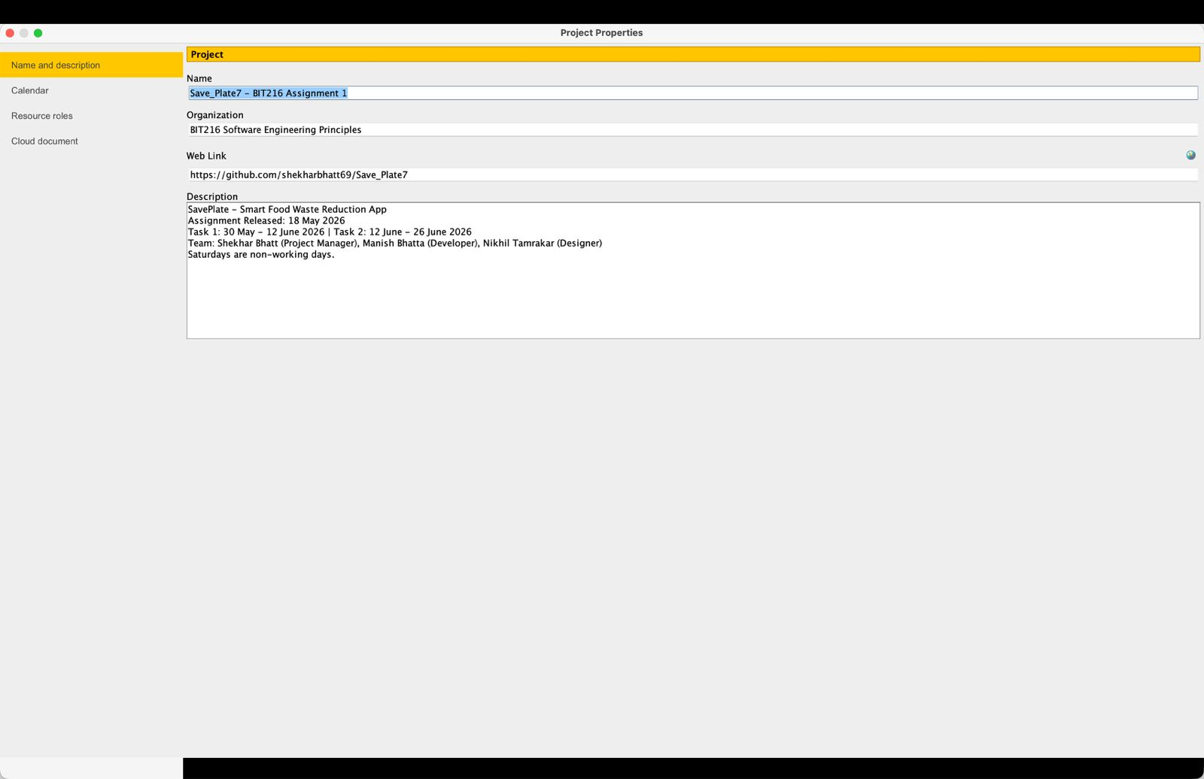
Figure 1: SavePlate Gantt Chart (30 May – 12 June 2026)
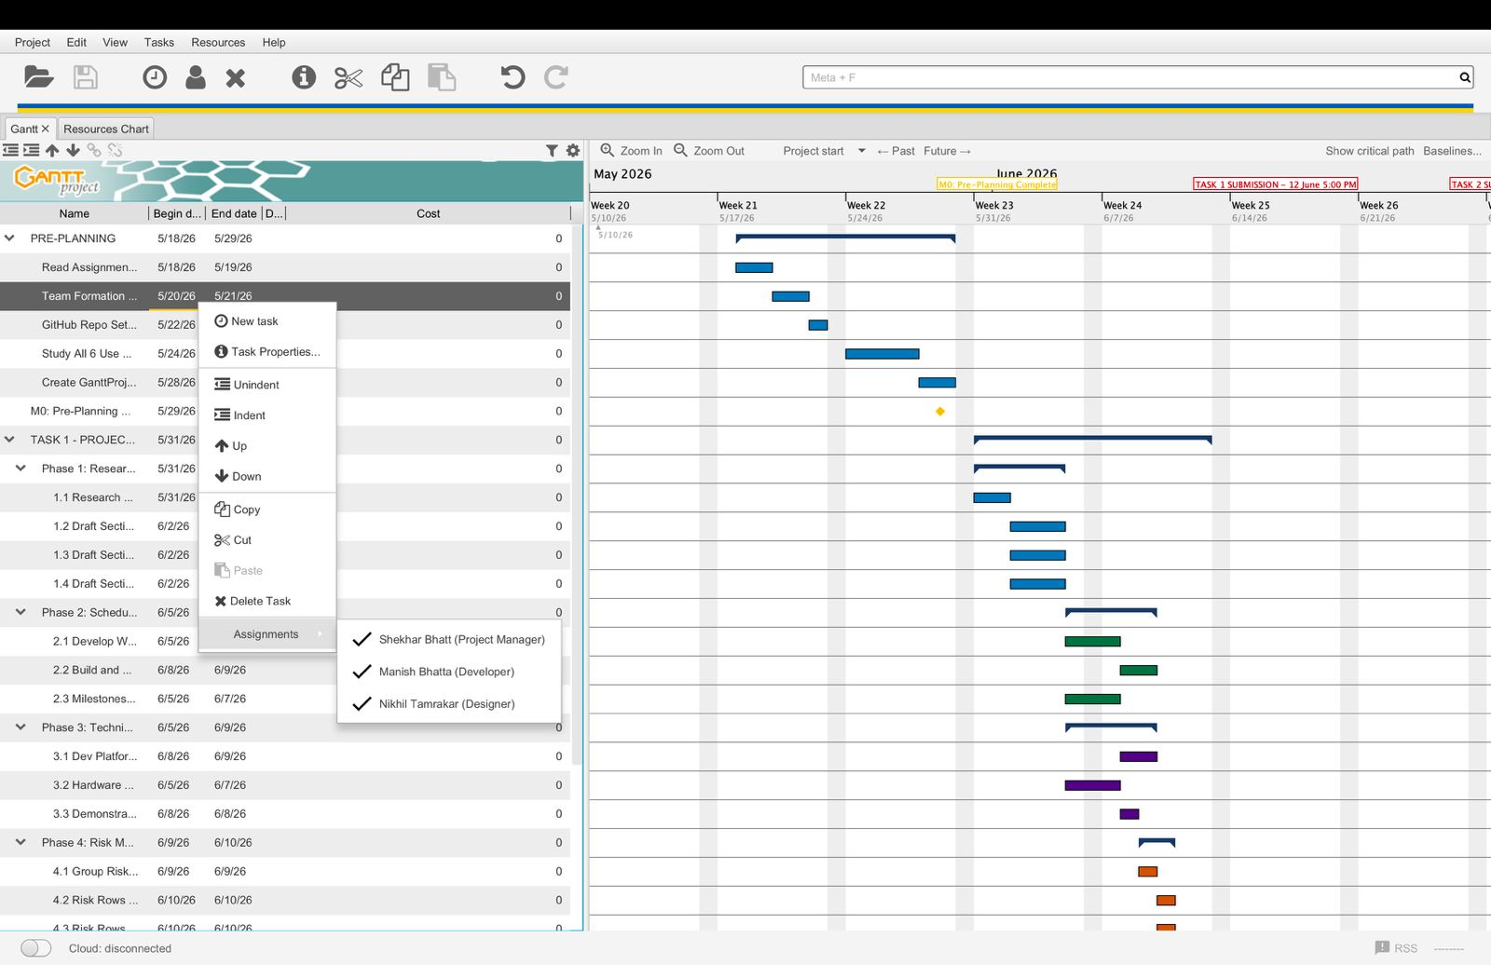

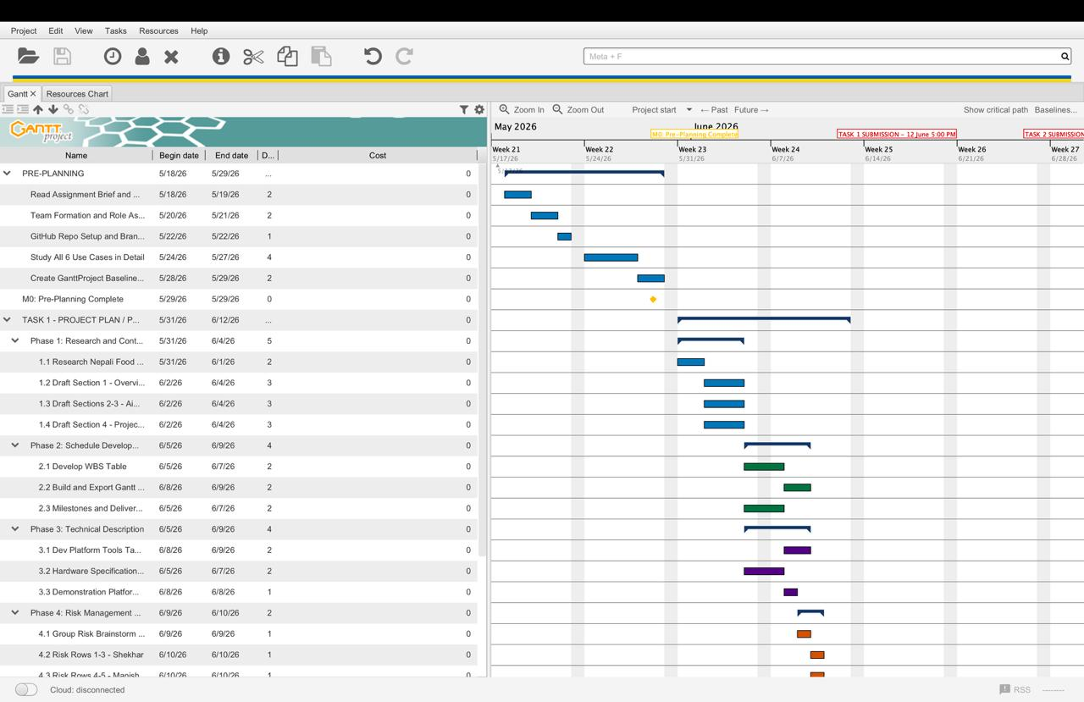
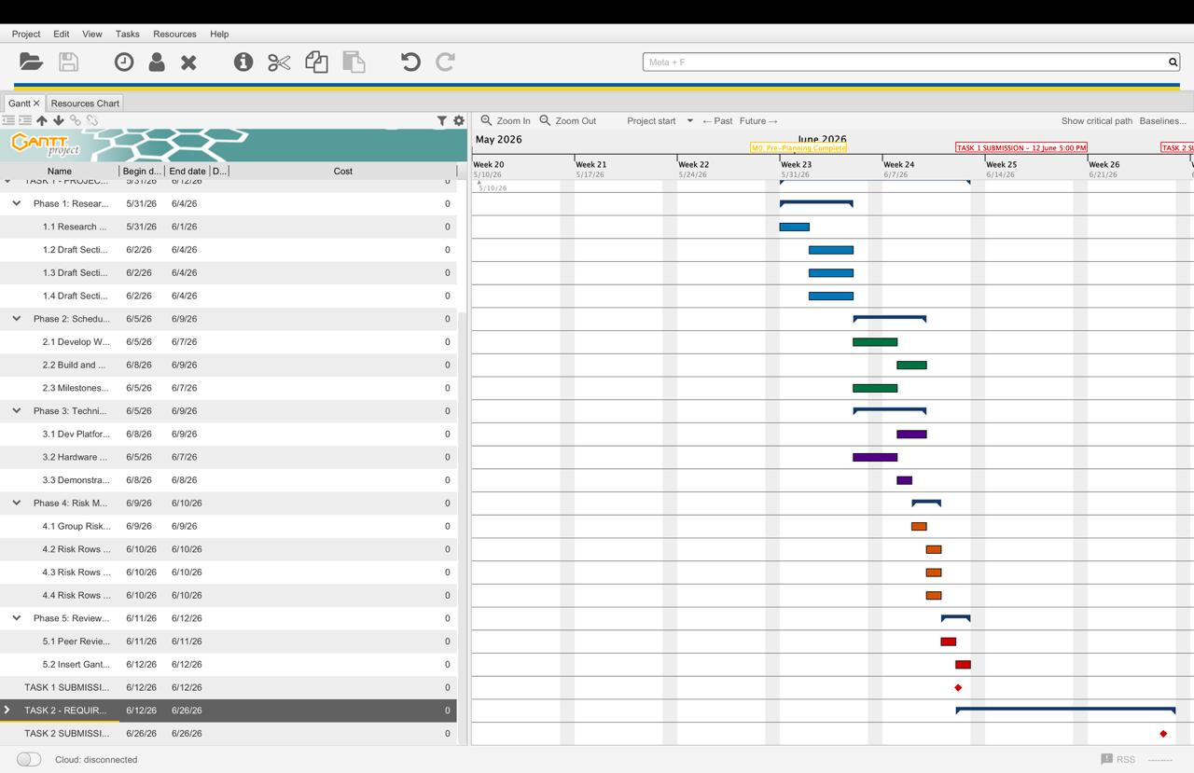

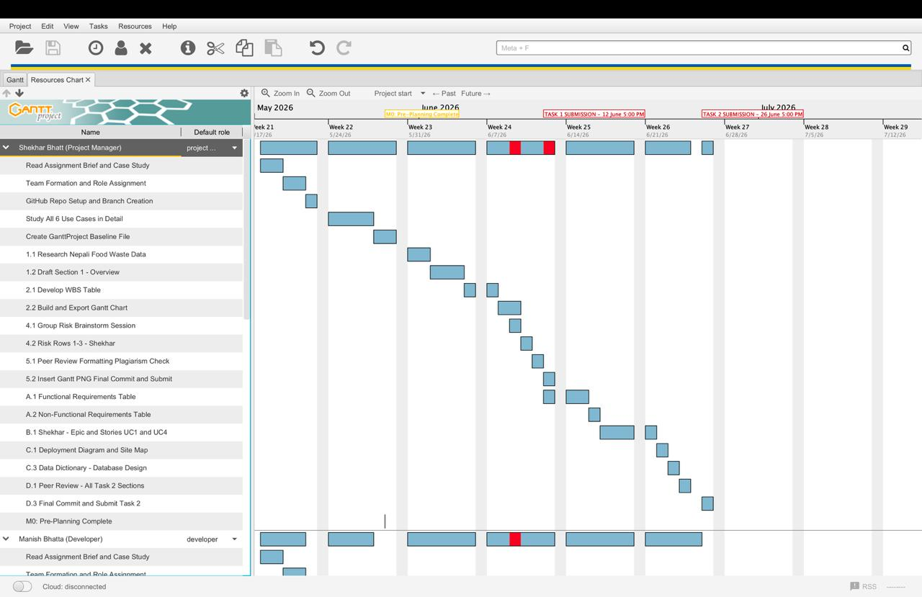

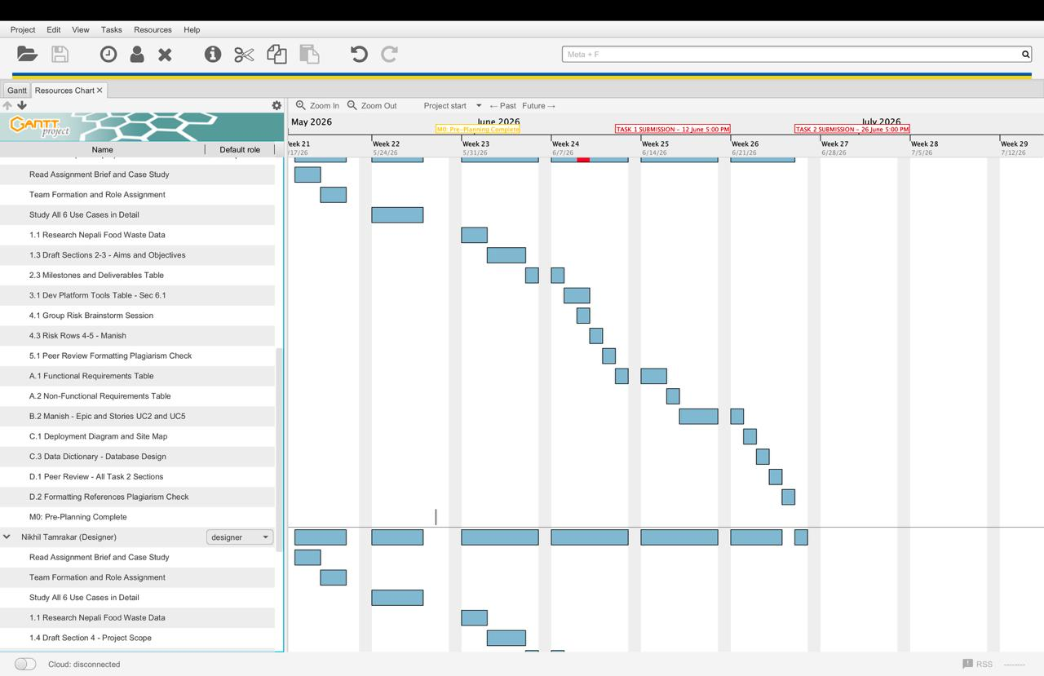

5.1 Work Breakdown Structure
Below is a work breakdown structure for Task 1 into five phases. Every task is associated with an owner and with dates indicating when it should be started and when it should be completed, and with an output it engenders.
ID | Task | Owner | Start | End | Deliverable
1.0 | Research and Drafting | All | 30 May | 2 Jun | Sections 1–4 drafted
1.1 | Research Nepali food waste data | All | 30 May | 31 May | Reference list
1.2 | Draft Section 1 — Overview | Shekhar | 1 Jun | 2 Jun | Overview section
1.3 | Draft Sections 2–3 — Aims, Objectives | Manish | 1 Jun | 3 Jun | Aims and objectives
1.4 | Draft Section 4 — Scope | Nikhil | 1 Jun | 3 Jun | Scope section
2.0 | Schedule Development | Shekhar | 4 Jun | 8 Jun | Section 5 complete
2.1 | Develop WBS table | Shekhar | 4 Jun | 5 Jun | WBS table
2.2 | Build and export Gantt chart | Shekhar | 7 Jun | 8 Jun | Gantt chart image
2.3 | Milestones table | Manish | 4 Jun | 5 Jun | Milestones table
3.0 | Technical Description | All | 4 Jun | 8 Jun | Section 6 complete
3.1 | Development tools table (6.1) | Manish | 7 Jun | 8 Jun | Tools table
3.2 | Hardware table (6.2) | Nikhil | 4 Jun | 5 Jun | Hardware table
3.3 | Demonstration table (6.3) | Nikhil | 7 Jun | 7 Jun | Demo table
4.0 | Risk Management | All | 8 Jun | 9 Jun | Section 7 complete
4.1 | Risk brainstorm session | All | 8 Jun | 8 Jun | Risk list
4.2 | Risk rows 1–3 | Shekhar | 9 Jun | 9 Jun | Three risks
4.3 | Risk rows 4–5 | Manish | 9 Jun | 9 Jun | Two risks
4.4 | Risk rows 6–7 | Nikhil | 9 Jun | 9 Jun | Two risks
5.0 | Review and Submit | All | 10 Jun | 12 Jun | Final document
5.1 | Peer review and formatting | All | 10 Jun | 10 Jun | Reviewed draft
5.2 | Insert Gantt, final commit | Shekhar | 11 Jun | 11 Jun | Final document
5.3 | Submit to Turnitin | All | 12 Jun | 12 Jun | Submitted

